# Instructions to Edit

To edit the site, open the 1&1 hosting page and select the webspace explorer section

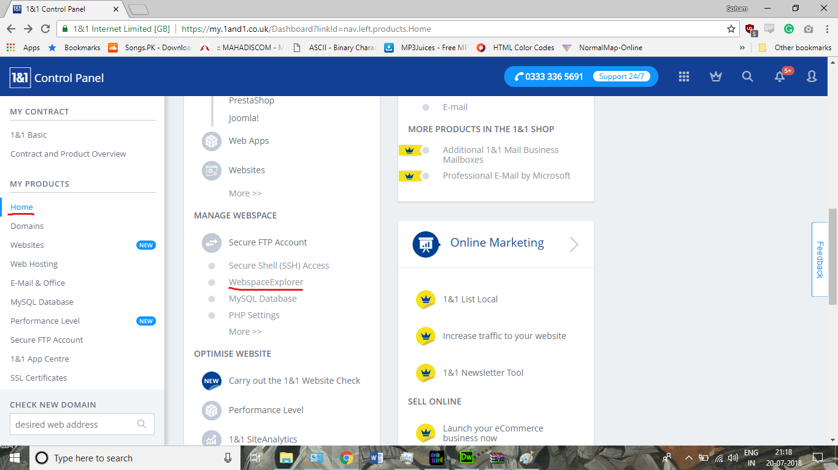

Then in the explorer go in the folder “site”. The files in this folder make the entire website. You can edit them from here

